Data Structures and Practice #7
Department: Cyber security Student ID: 201820696 Name: Yu Jeong Hyep
Topic | Binary Tree Traversal
Learning objectives | The students can understand the binary tree traversal algorithms
Basic data structure | typedef struct TreeNode *TreePointer;  typedef struct TreeNode {  int data;  TreePointer leftChild; TreePointer rightChild;  } TreeNode;  void inorder(TreePointer ptr)  {  if (ptr) {  inorder(ptr->leftChild); printf("%d ", ptr->data); inorder(ptr->rightChild);  }  return;  }  void preorder(TreePointer ptr)  {  if (ptr) {  printf("%d ", ptr->data); preorder(ptr->leftChild); preorder(ptr->rightChild);  }  return;  }  void postorder(TreePointer ptr)  {  if (ptr) {  postorder(ptr->leftChild); postorder(ptr->rightChild); printf("%d ", ptr->data);  }  return;  }
Problem 1  [20 points] | 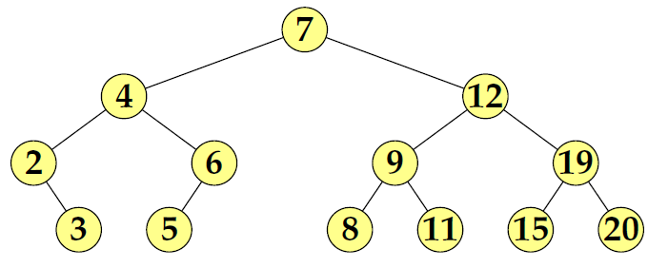  1) Show the results of Inorder traversal.  2 3 4 5 6 7 8 9 11 12 15 19 20  2) Show the results of Preorder traversal  .  7 4 2 3 6 5 12 9 8 11 19 15 20  3) Show the results of Postorder traversal.  3 2 5 6 4 8 11 9 15 20 19 12 7
Problem 2  [20 points] | Draw the shape of each tree when the results of Inorder traversal and Preorder traversal are given like the followings (Note: Show the reasoning process.)  1) inorder: 4 2 5 1 3, preorder: 1 2 4 5 3  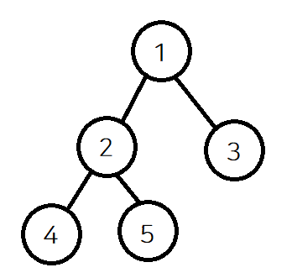  Pre order’s first node is 1. So we know a node of level 0 is 1. And we can know 3 is right child of 1 because, in-order 3 is right of 1. Preorder’s second node is 2 so we know level 0 (1)’s left child is 2. And also preorder’s third node is 4, we can know level 1(2)’s left child is 4. And last 5 is 2’s right child.  2) inorder: 4 2 5 1 8 6 9 3 7, preorder: 1 2 4 5 3 6 8 9 7  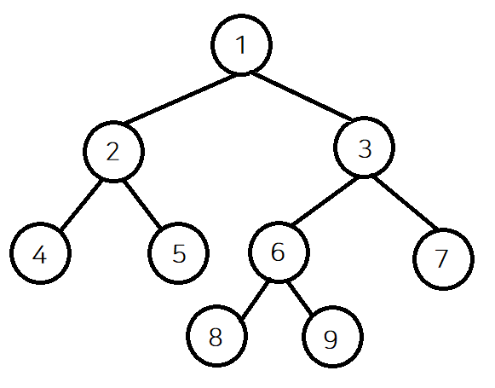  First, we know a node of level 0 is 1 because preorder’s first node is 1. Then we can judge the left side of 1 is 4, 2, 5, and 8, 6, 9, 3, 7 is right side of 1 to see inorder traversal. In the left side, we know 2 is left child of 1 in preorder. So we can find 4 is left child of 2, 5 is right child in inorder. In the right side, we know 3 is right child of 1 in preorder because nodes of left side finish. So we can find 8, 6, 9 is left side of 3, 7 is right child of 3. 6 is left child of 3 in preorder, and 8 is left child of 6, 9 is right child of 9. Then we can draw the shape of tree.
Problem 3  [20 points] | 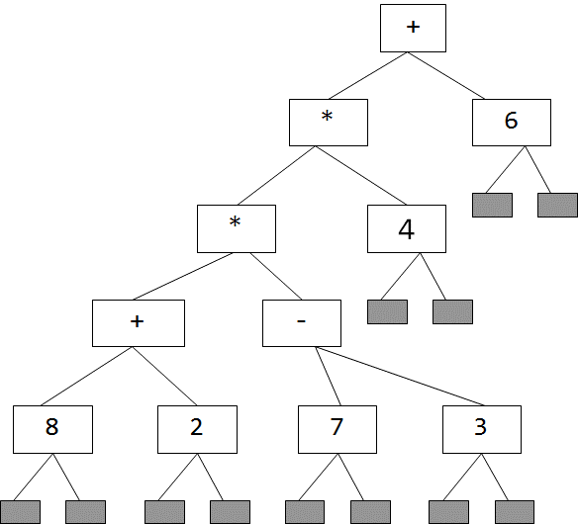 | 1) Show the Inorder traversal result.  (((8+2)*(7-3))*4)+6  2) Show the Preorder traversal result.  +(*(*(+82)(-73))4)6  3) Show the Postorder traversal result.  (((82+)(73-)*)4*)6+
Problem 4  [40 points] | 1) When a tree is given like below select the proper traversal algorithm to evaluate the expression. Show why your selection is reasonable.  Postorder is proper traversal to evaluate the expression. Because, Computer use stack data structure, it is easy to evaluate postfix expression.  2) Show how to change the basic data structure to get the evaluation results of the expression. Assume that the operators are limited to +, -, *, and /. The operands are limited to integer.  typedef struct TreeNode *TreePointer;  typedef struct TreeNode {  char op;  int operand;  int data;  TreePointer leftChild, rightChild;  } TreeNode;  3) Show how to change the traversal code to get the expression evaluation result. (Note: Refer to the postOrderEval() in the lecture note)  Void postOrderEval(Treepointer Node){  If (node){  postOrderEval(Node->leftChild);  postOrderEval(Node->rightChild);  if(Node->op == ‘+’ || Node->op == ‘-‘ || Node->op == ‘/’ || Node -> op == ’*’){  switch(Node->op){  case ‘+’:  Node->operand = Node ->leftChild->operand + Node ->rightChild->operand; break;  case ‘-’:  Node->operand = Node ->leftChild->operand - Node ->rightChild->operand; break;  case ‘*’:  Node->operand = Node ->leftChild->operand * Node ->rightChild->operand; break;  case ‘/’:  Node->operand = Node ->leftChild->operand / Node ->rightChild->operand; break;  Default: break;  }  }  Else if(Node -> operand ==NULL){  Return;  }  }  }

